Negative images
Code:
import cv2
image = cv2.imread('arda.jpg')
if image is None:
exit()
negative_image = 255 - image
cv2.imshow('Original Image', image)
cv2.imshow('Negative Image', negative_image)
cv2.waitKey(0)
cv2.destroyAllWindows()
Code Explanation:
- Loading the Image:
image = cv2.imread('arda.jpg')
  - The image 'arda.jpg' is loaded into memory.
- Check if Image Exists:
if image is None:
exit()
  - If the image isn't loaded properly, the program exits.
- Create Negative Image:
negative_image = 255 - image
  - The negative of the image is created by subtracting each pixel value from 255.
- Display the Images:
cv2.imshow('Original Image', image)
cv2.imshow('Negative Image', negative_image)
  - The original and negative images are displayed in separate windows.
- Wait for Key Press:
cv2.waitKey(0)
cv2.destroyAllWindows()
  - Waits for a key press and then closes the image windows.
output:

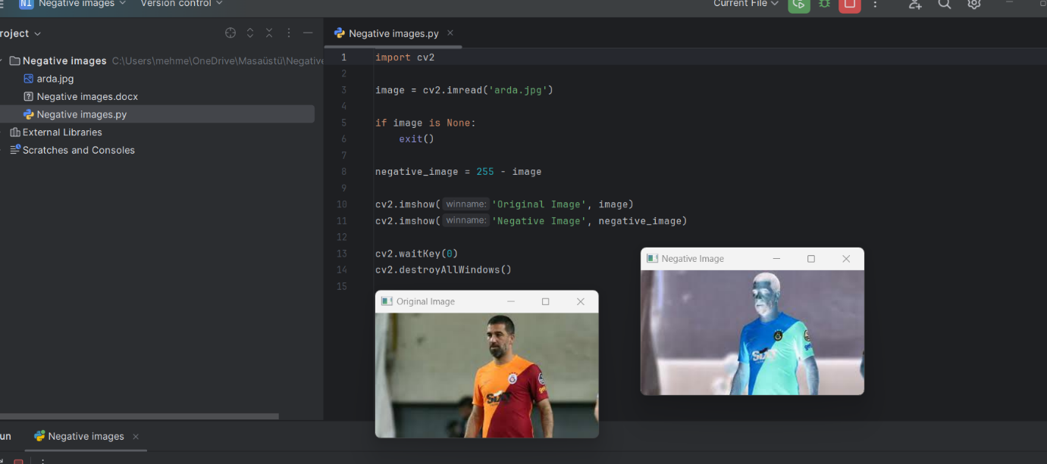
Report:
This code demonstrates how to create and display the negative of an image using OpenCV. By subtracting each pixel's value from 255, the image's colors are inverted. The original and negative images are then displayed for comparison. This technique is often used for visual effects or analysis in image processing tasks.

